# CS 340 README Template

Justin Fields

7-2

*Use this template to complete your README file. When completing the template, keep the headings as they are so that your document has a clear organization. Remove the italicized prompt text after you have completed each section for a polished final document.*

## About the Project/Project Title

*Provide a little information about your project or an overview that explains* ***what*** *the project is about.*

*OK it is assignment 7-2. This project is a combination of all my module projects that I submit it but it’s also I have to add more information to those modules. I have to add more programming to some of them.*

## Motivation

*This is a short description of the motivation behind the creation and maintenance of the project. This should explain* ***why*** *the project exists.*

I think this project overall is a way for me to combine all that I know from this class up to this point and combined them together to create an almost create Per folio. Creating the dashboard for all the animals that are in the database. It also has charts and an map. I have dashboard and widget functionality.

## Getting Started

*This is an example of how you may give instructions on setting up your project locally: “To get a local copy up and running, follow these simple example steps.”*

## Installation

*List the tools you need to use the software and how to install them.*

*All the tools that I use was Jupiter application Python language and mongo Application.*

## Usage

*Use this space to show useful examples of how your project works and how it can be used. Be sure to include examples of your code, tests, and screenshots.*

### Code Example

*Show what the library does as concisely as possible. Developers should be able to figure out how your project solves their problem by looking at the code example. Make sure that your code is* *short and concise.*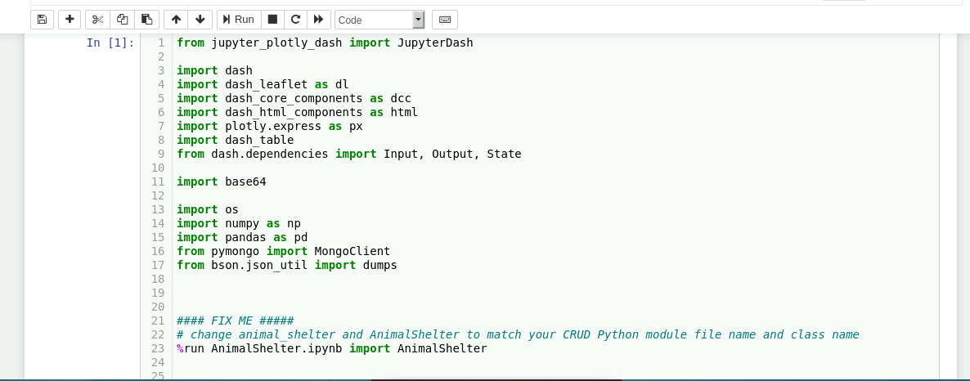

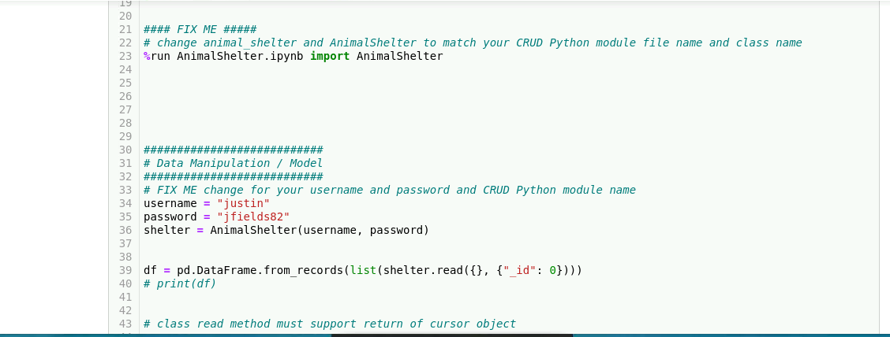

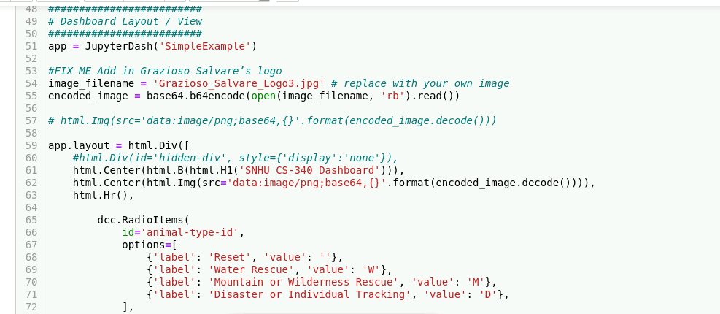

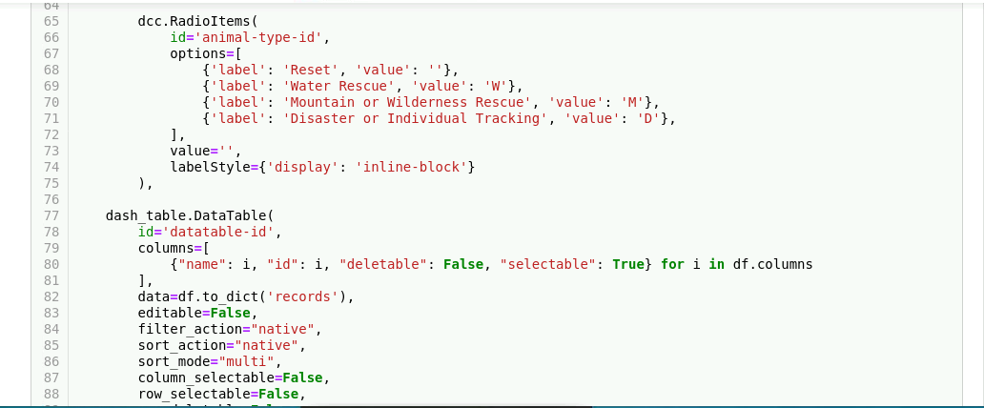

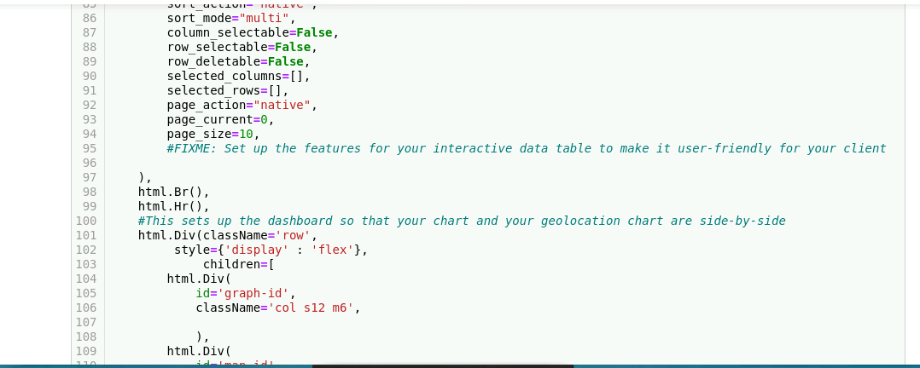

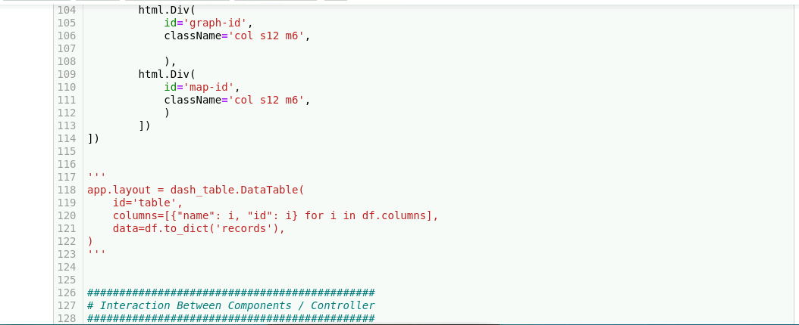

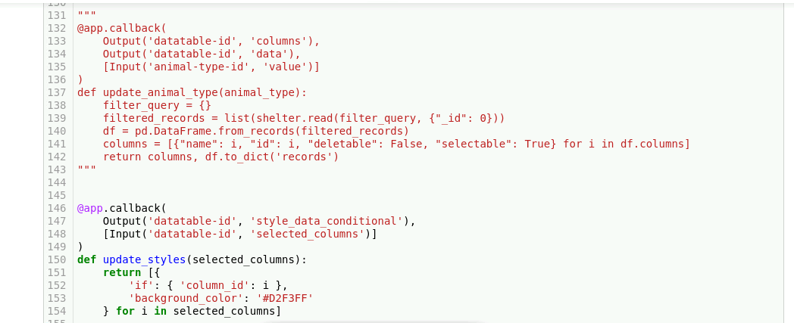

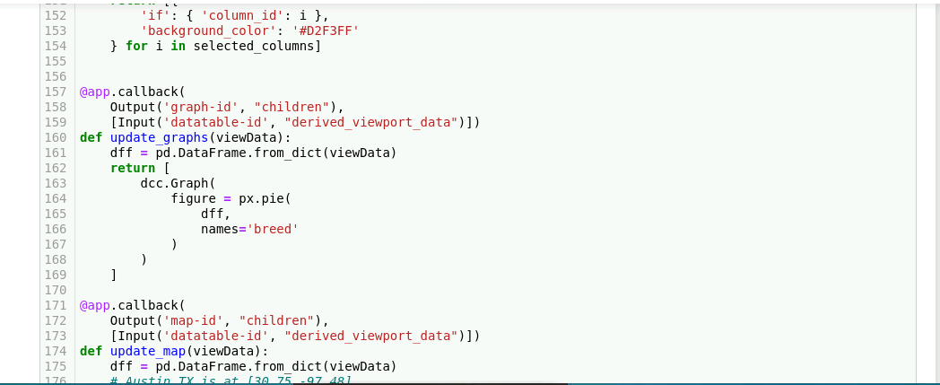

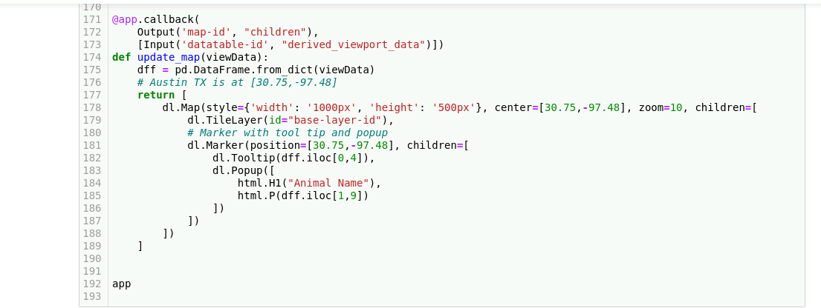

### Tests

*Describe and show how to run the tests with code examples.*

Type in the animal let cat you want then click enter. When this happens, it will give you list of cats with a chart and a map of cats. This also works with dogs as well. I have dashboard and widget functionality.

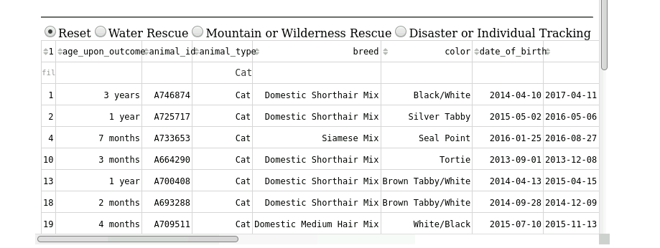

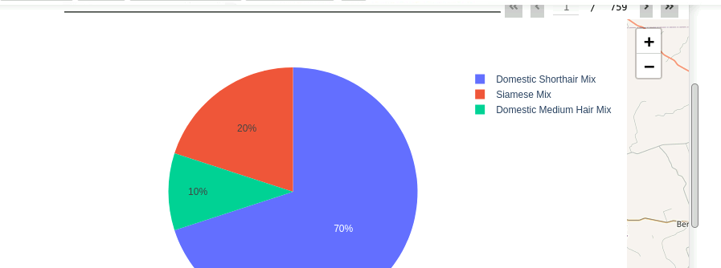

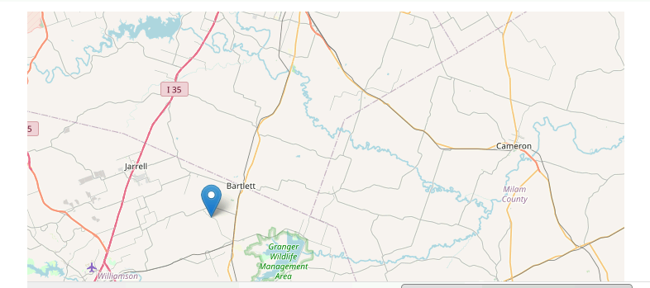

### Screenshots

*Provide screenshots that demonstrate your work.*

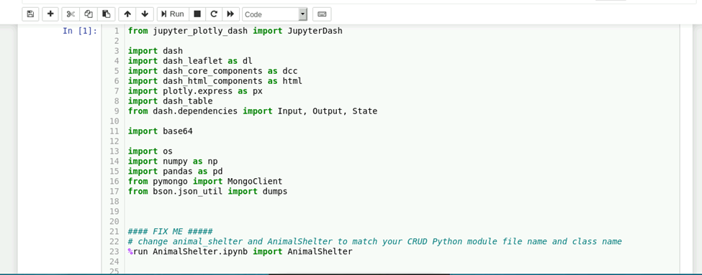

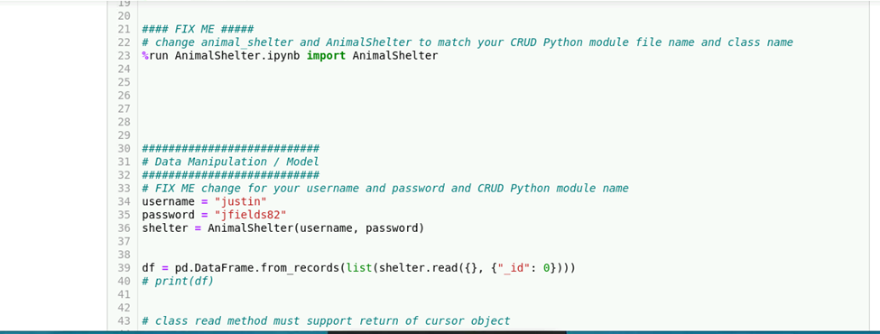

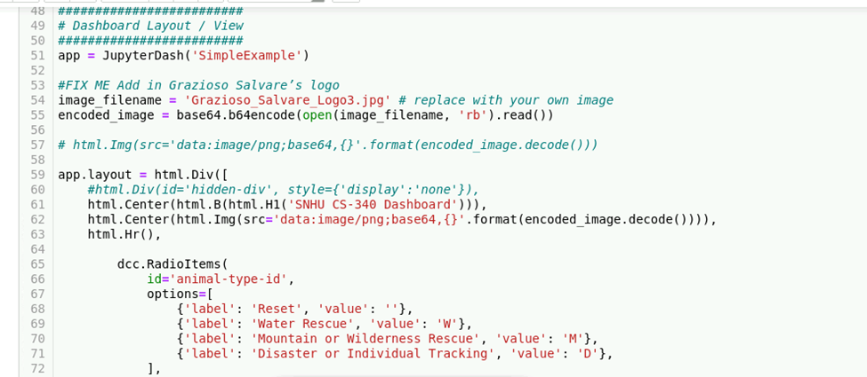

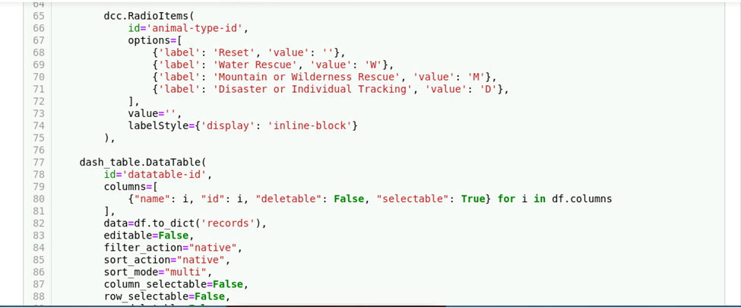

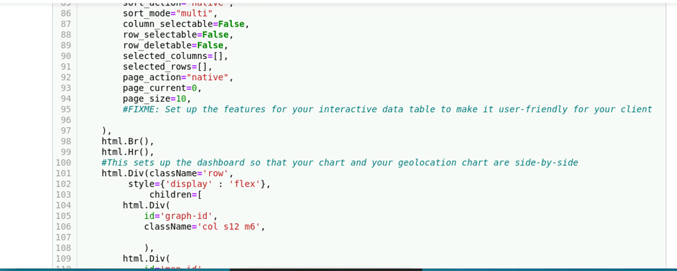

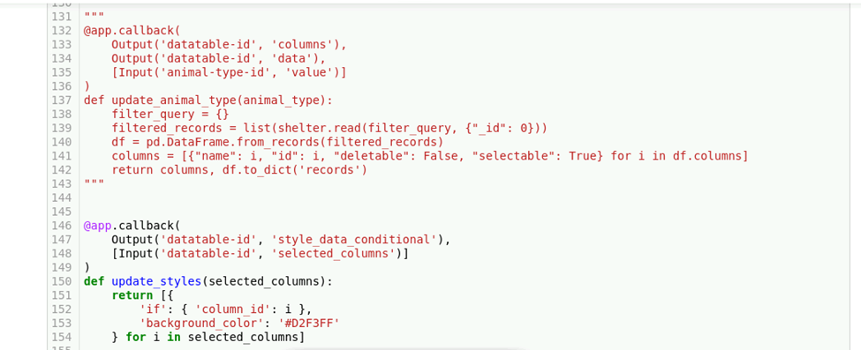

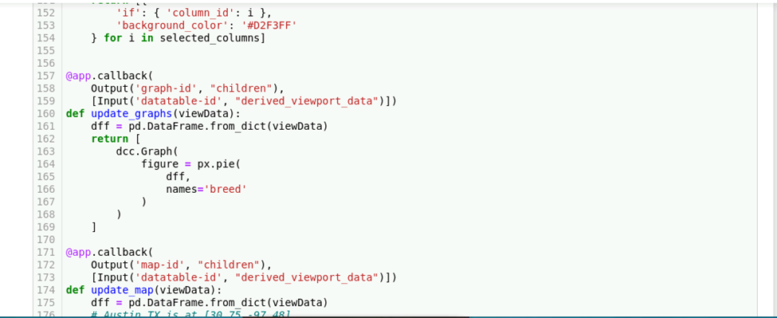

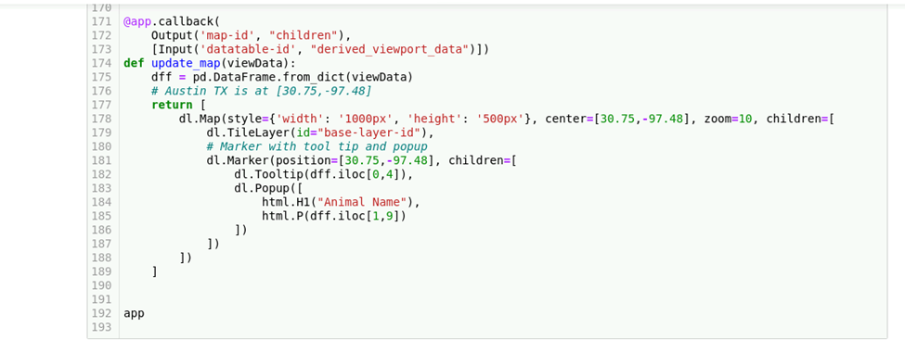

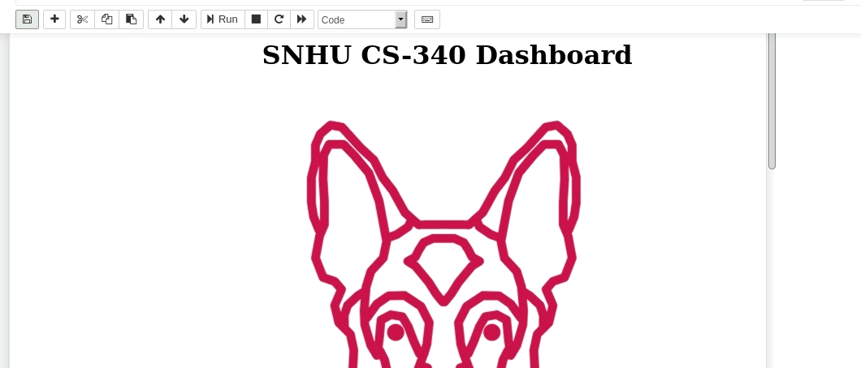

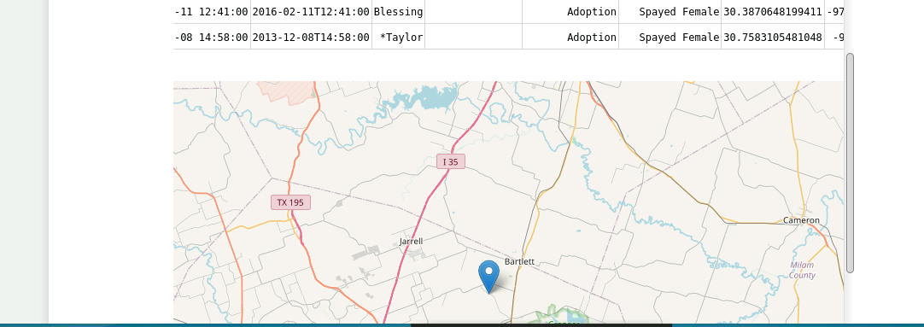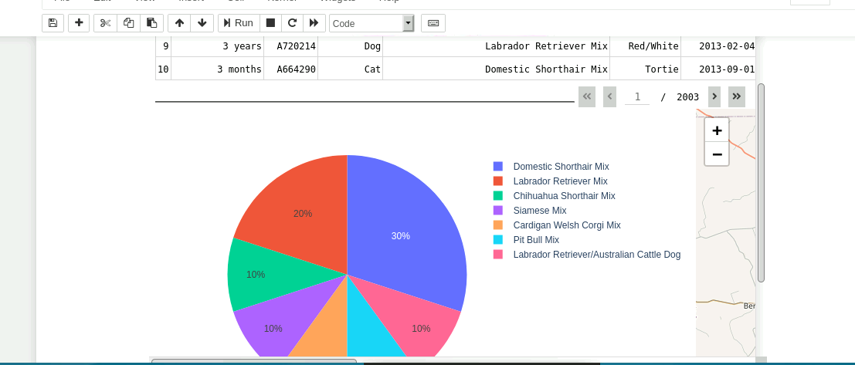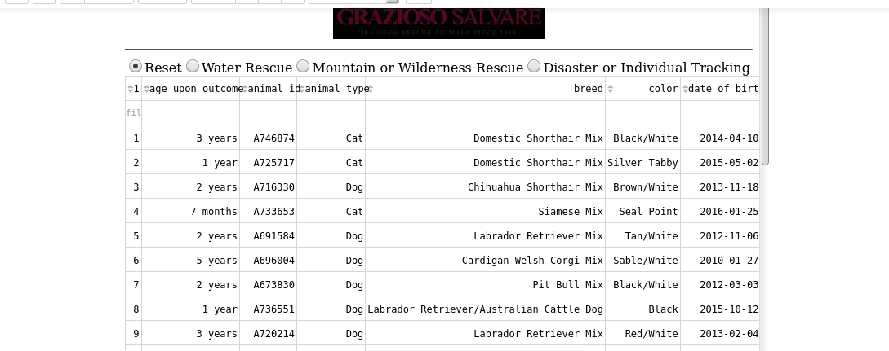

## Roadmap/Features (Optional)

*Provide an open issues list of proposed features (and known issues). If you have ideas for releases in the future, it is a good idea to list them in the README. What makes your project stand out?  
  
Note: This section is optional for the purposes of this assignment. If you choose not to fill out this section, remove it from your final README file.*

## Contact

Your name: Justin Fields